 enumerate a Microsoft SQL database

McDatabaseAdmin came rushing into the room and cried to McSkidy, “We’ve been locked out of the reindeer schedule - how will Santa’s transportation work for Christmas?” The grinch has locked McDatabaseAdmin of his system. You need to probe the external surface of the server to see if you get him his access back.

MS SQL Server is a Relational Database Management System (RDBMS). One simple way to think of a relational database is a group of tables that have relations. To gain a rough understanding of relational databases work, consider a shop's database with the following three tables:

1. Electronic Items
2. Customers
3. Invoices

Each item in the Electronic Items table has:

* ID
* Name
* Price
* Quantity

Each item in the Customers table has its own attributes as well:

* ID
* Name
* Email
* Phone

Finally, the Invoices table will refer to a customer and one or more electronic items. The Invoice table will refer to an “entity” from another table using its ID. This way, we only need to have the customer details and electronic item details written once instead of copying them to each new invoice. This case is a simplified example of a relational database. The figure below shows how the three tables are related.

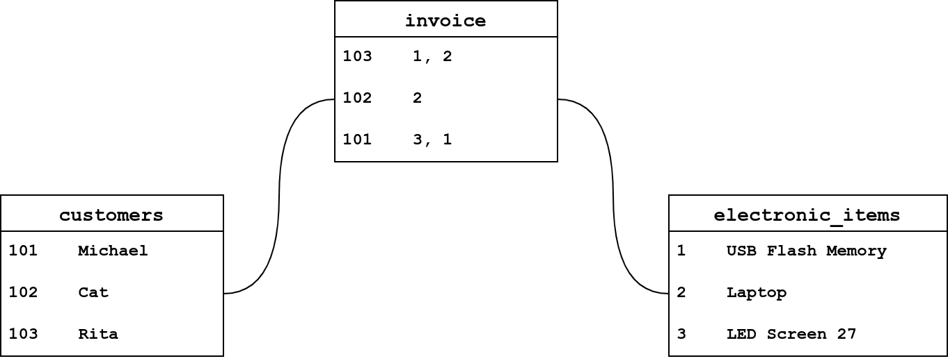

The transportation schedule is in the reindeer database. However, McDatabaseAdmin can no longer log in to his system after the grinch changed the system password. Let’s see how we can help. Make sure you have started the attached Machine along with the AttackBox. Give them a few minutes to fully start before proceeding to answer the following questions.



***Answer the questions below***

You decided that the first step would be to check the running services on 10.10.24.238. You resort to yesterday’s tool, Nmap.

Knowing that 10.10.24.238 is a MS Windows system, you expect it to not respond to ping probes by default; therefore, you need to add -Pn to your nmap command to perform the scan. This instructs Nmap to skip pinging the target to see if the host is reachable. Without this option, Nmap will assume the target host is offline and not proceed with scanning.

There is an open port related to MS SQL Server accessible over the network. What is the port number?



Correct Answer

Knowing the MS SQL Server is running and accessible over the network, we want to check if our username and password are still valid. Using the AttackBox terminal, we will use the command sqsh (pronounced skwish), an interactive database shell.

A simple syntax would be sqsh -S server -U username -P password, where:

* -S server is used to specify the server, for example -S 10.10.24.238
* -U username is used to provide the username; for example, -U sa is the username that we have enabled.
* -P password lets us specify the password.

Let’s try to run, sqsh -S 10.10.24.238 -U sa -P t7uLKzddQzVjVFJp

If the connection is successful, you will get a prompt. What is the prompt that you have received?



Correct Answer

McDatabaseAdmin told us the database name is reindeer and it has three tables:

1. names
2. presents
3. schedule

To display the table names, you could use the following syntax, SELECT * FROM table_name WHERE condition.

* SELECT * is used to return specific columns (attributes). * refers to all the columns.
* FROM table_name to specify the table you want to read from.
* WHERE condition to specify the rows (entities).

In the terminal below, we executed the query, SELECT * FROM reindeer.dbo.names;. This SQL query should dump all the contents of the table names from the database reindeer. Note that the ; indicates the end of the SQL query, while go sends a SQL batch to the database.

Pentester Terminal

pentester@TryHackMe**$** sqsh -S 10.10.24.238 -U sa -P "t7uLKzddQzVjVFJp"

1> SELECT * FROM reindeer.dbo.names;

2> go

id first last nickname

----------- ---------------------------------------- ---------------------------------------- ----------------------------------------

1 Dasher Dasher Dasher

2 Dancer Dancer Dancer

3 Prancer Prancer Prancer

4 Vixen Vixen Vixen

5 Comet Comet Comet

6 Cupid Cupid Cupid

7 Donner Donder Dunder

8 Blitzen Blixem Blitzen

9 Rudolph Reindeer Red Nosed

(9 rows affected)

We can see four columns in the table displayed above: id, first (name), last (name), and nickname. What is the first name of the reindeer of id 9?



Correct Answer

 Hint

Check the table schedule. What is the destination of the trip scheduled on December 7?



Correct Answer

 Hint

Check the table presents. What is the quantity available for the present “Power Bank”?



Correct Answer

 Hint

You have done fantastic work! You have helped McDatabaseAdmin retrieve the schedule! Now, let’s see if we can run MS Windows commands while interacting with the database. Some MS SQL Servers have xp_cmdshell enabled. If this is the case, we might have access to something similar to a command prompt.

The command syntax is xp_cmdshell 'COMMAND';. Let’s try a simple command, whoami, which shows the user running the commands. In the terminal output below, after connecting to MS SQL Server, we tried xp_cmdshell 'whoami';, and we can see that the user is nt service\mssqlserver. This means that any command we pass to xp_cmdshell will run as nt service\mssqlserver.

Pentester Terminal

pentester@TryHackMe**$** sqsh -S 10.10.24.238 -U sa -P "t7uLKzddQzVjVFJp"

1> xp_cmdshell 'whoami';

2> go

output

[...]

nt service\mssqlserver

NULL

(2 rows affected, return status = 0)

We can run other commands that we can execute on the MS Windows command line. For example, we can use dir to list files and directories and type filename to display the contents of a file. Consider the example in the terminal window below where we reveal the contents of the text file WindowsUpdate.log.

Pentester Terminal

pentester@TryHackMe**$** sqsh -S 10.10.24.238 -U sa -P "t7uLKzddQzVjVFJp"

sqsh-2.5.16.1 Copyright (C) 1995-2001 Scott C. Gray

Portions Copyright (C) 2004-2014 Michael Peppler and Martin Wesdorp

This is free software with ABSOLUTELY NO WARRANTY

For more information type '\warranty'

1> xp_cmdshell 'type c:\windows\WindowsUpdate.log';

2> go

output

[...]

Windows Update logs are now generated using ETW (Event Tracing for Windows).

Please run the Get-WindowsUpdateLog PowerShell command to convert ETW traces into a readable WindowsUpdate.log.

NULL

NULL

For more information, please visit https://go.microsoft.com/fwlink/?LinkId=518345

(5 rows affected, return status = 0)

1>

There is a flag hidden in the grinch user's home directory. What are its contents?

Use of type is for accessing file

 Hint

Congratulations, the flag you have recovered contains the password of McDatabaseAdmin! In this task, we learned how to use sqsh to interact with a MS SQL Server. We learned that if xp_cmdshell is enabled, we can execute system commands and read the output using sqsh.